# Project Exam 1

Kiri Kvistnes

1483 words

## Design

### What went well on the project

I quickly decided on which theme I wanted for the blog; Traveling through Norway. It would be a fictional blog by a fictional person (John Doe), where he documents his journey through Norway. I had a clear vision of what I wanted the page to look like, and therefore I did not spend much time creating a high-fidelity prototype for both mobile screens and desktops, so I focused on getting a high-fidelity prototype for desktop screens, and low fidelity for smaller screens. If I had a customer, I would have made a high-fidelity prototype for mobile screens too, to get feedback from the customer before I started creating the blog itself.

I wanted a simple and minimalistic blog, where text and images should get as much attention as possible. I landed on an “earth tone” palette, but after feedback that "the page needs colors", I implemented small details with a light teal color, as you can see in the navigation underline when hovered or on the current pages.

I ended up with four different fonts from Adobe Fonts[1], which may be too many, but I think they complement eachother and gives a little life to the site because the colours are so calm. The logo and the signature have the Viktor font, and I wanted it to give a personal effect on the site, as if it is John Doe’s handwriting.

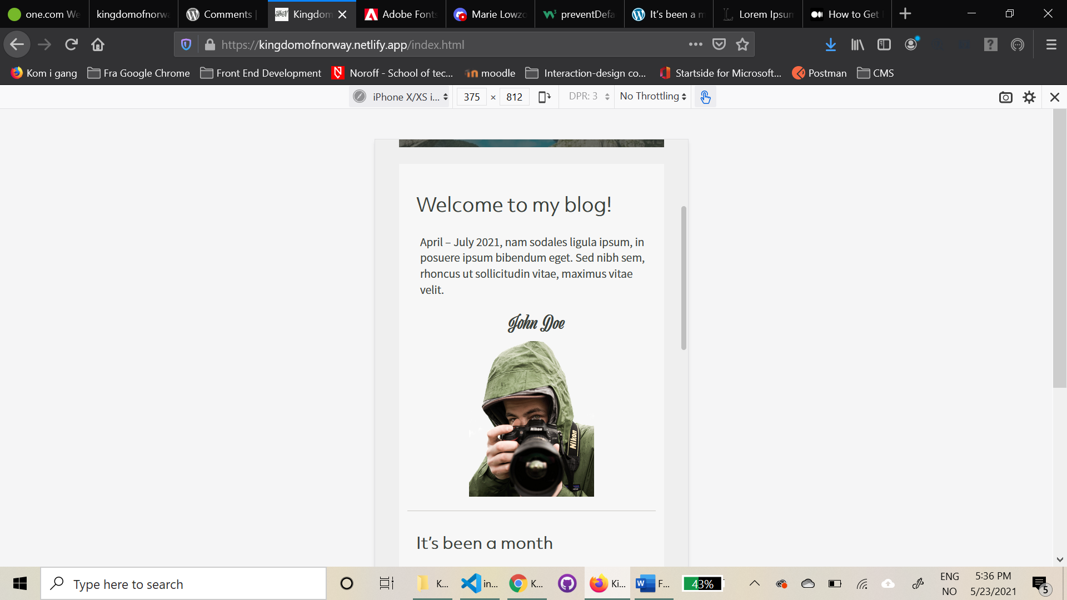

All images are from unsplash[2] and adobe stock[3]. I wanted images of hiking, kayaking, tents, bonfires, food, reindeers and dogs to get a realistic feel of the blog. I added a photograph of “John” to make the site more trustworthy, to show the user the face (or eyes) behind the blog.

I made a favicon in adobe illustrator with the same font as John’s handwriting, with the letters KoN as in Kingdom of Norway, the blog name.

### What was difficult/didn’t go well on the project

I did not like the feedback about the colours being “boring”. But sometimes you have to “kill your darlings” to make others happy.

### What would you do differently next time

Design and style for smaller screens first.

Figure

## Technical

### What went well on the project

I believe I managed to keep the HTML and CSS tidy, and I followed the DRY principle (Noroff Lesson). I’m not sure if I did a good job with the JavaScript, but I have made progress and learnt a lot during this project.

The previous MAs and CAs were quite helpful to me when I did not remember how to do something. Then I could just go back and look at how I solved similar tasks earlier.

I know I should have styled the site for smaller screens first, but I really prefer to design for desktop first, because I think it is easier to adjust it to smaller screens after. For my next project I will challenge myself to design for smaller screens first.

It went well creating a WordPress site, blog posts, pages and adding images to the media library.

### What was difficult/didn’t go well on the project

### Fetching images and posts

It was difficult to fetch the images. I came across a question on a forum about the same problem, and ended up with this article[4]. I implemented the parameter ?_embed and followed the tutorial. On some pages it worked, and others it did not. I got this TypeError in the console (figure 2):

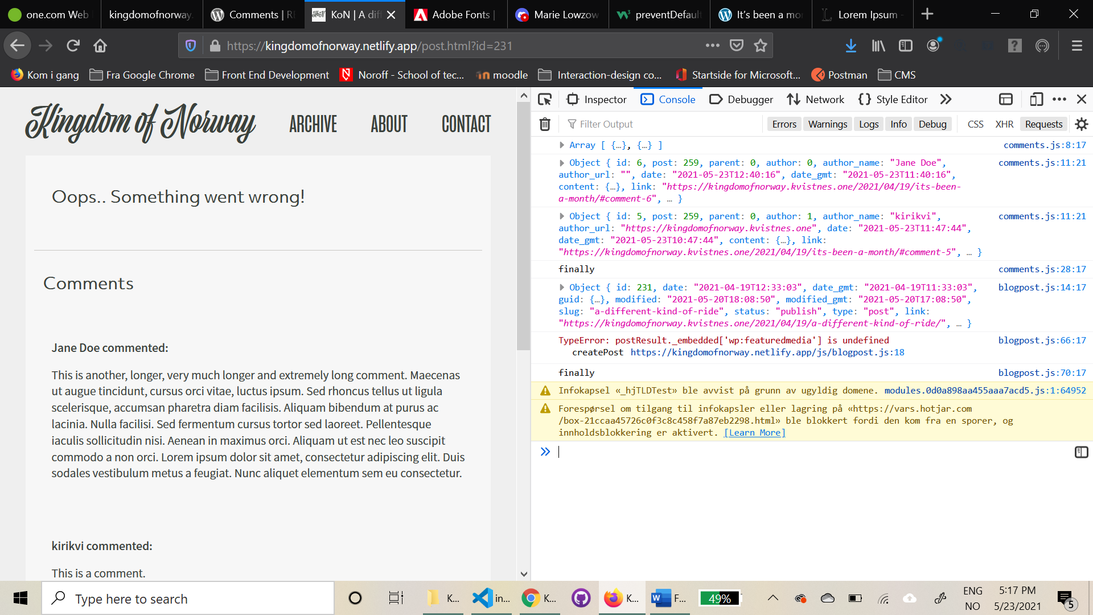

Figure 2

The strange thing is that the same code works on the other blog posts, so I think the problem must be within the data fetched from that specific post?

At first it did not work to load more than 10 posts from WordPress. I tried to find a way to fix the problem in the WordPress settings (figure 3), but after changing what I thought might work, it still returned 10 objects.

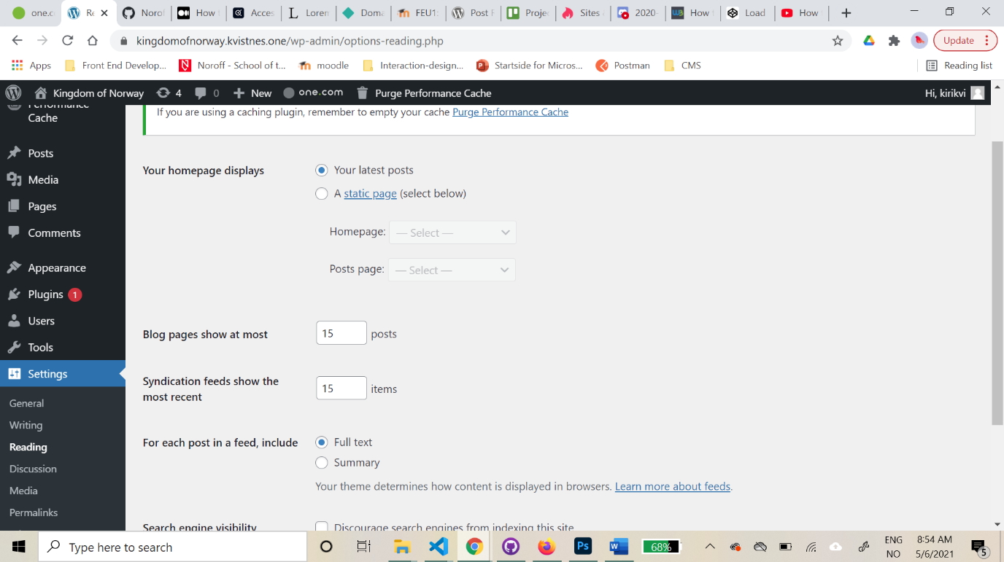

Figure 3

I googled the problem, and found a really helpful post[5] by someone who had the same problem as me. I found out it only returned 10 posts by default, so I had to add a new parameter (?per_page=15, figure 4) at the end of the url, which worked.

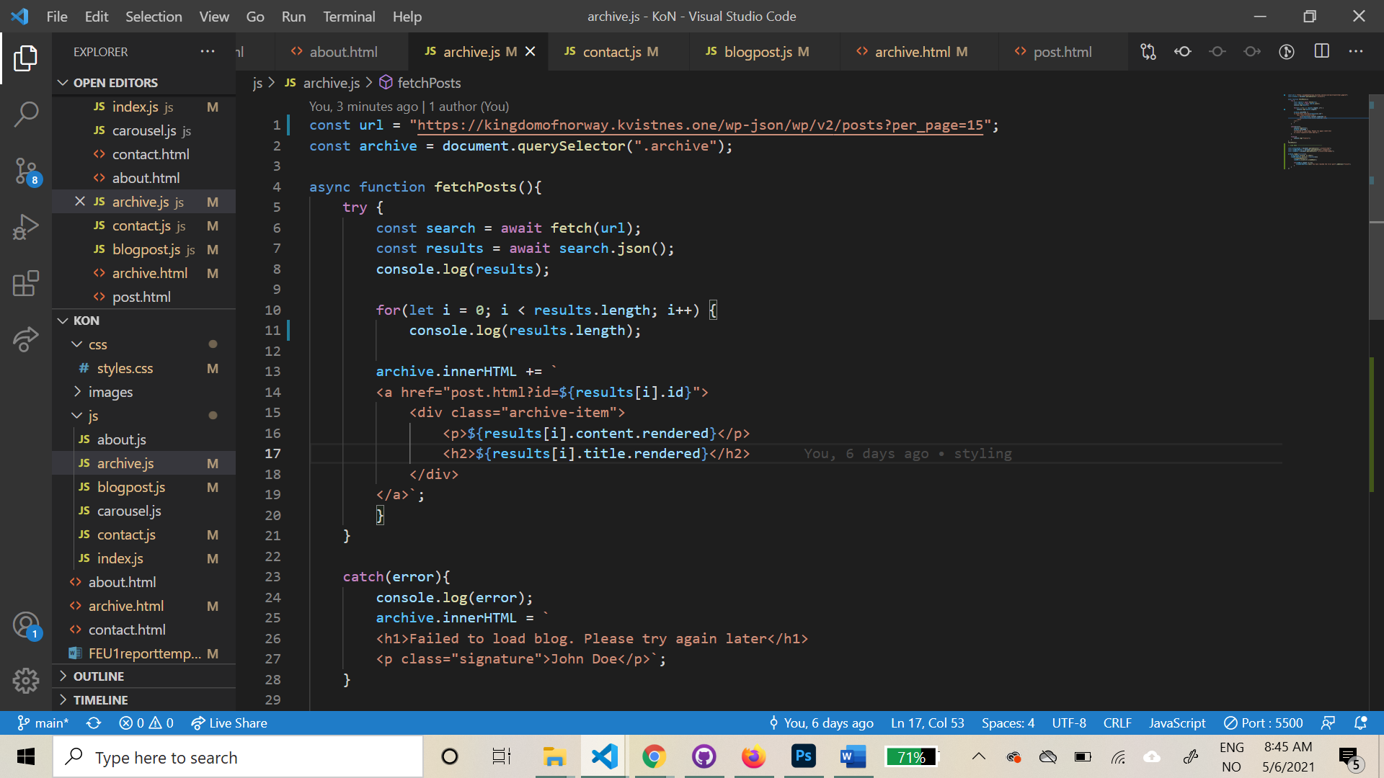

Figure 4

### Click to view more

On to how to view more than 10 posts. I struggled a bit to make it work, but after a lot of trying and failing, I did this: I made two for loops and an on click event for getting the last posts when clicking a button. I added code to hide the button when all posts are loaded, then added text for the user to know that they have reached the last post (figure 5).

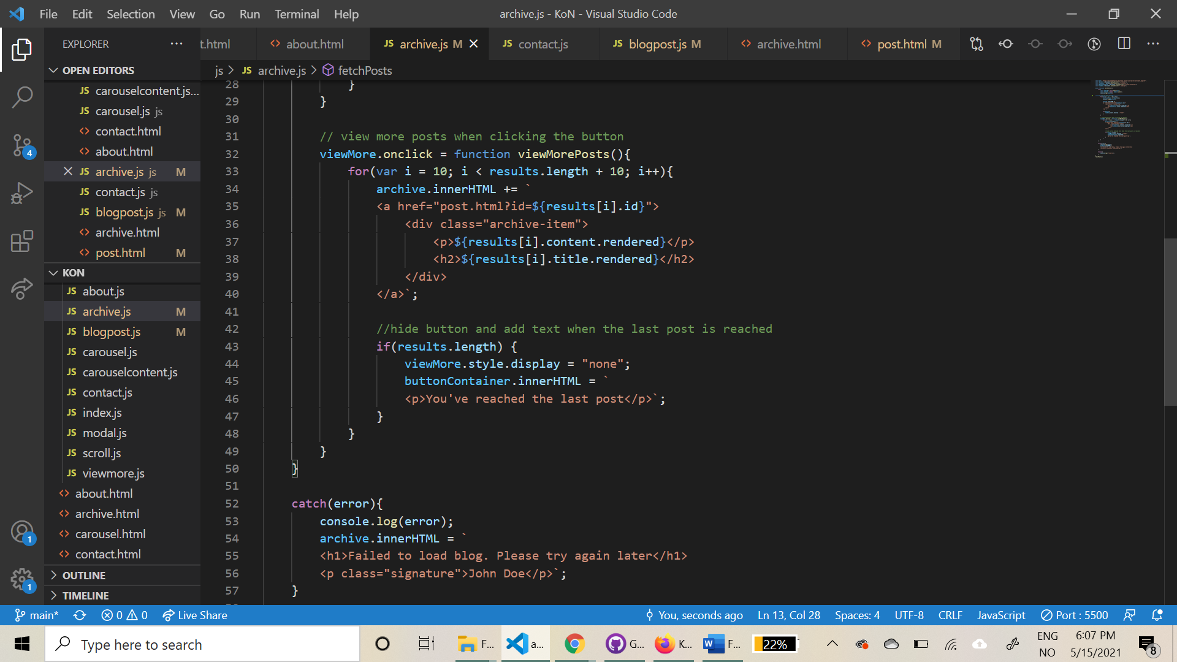

Figure 5

### The carousel

It was so hard figuring out how to make a carousel. I did not understand all the tutorials I came across, and many of them was a jQuery tutorial. I came across Kevin Powell’s youtube video[6] about how to make a carousel from scratch, and finally it worked!

I had (and still have) problems with the elements resizing when clicking left or right, and found a solution that almost worked. I tried to fix this the last day of the project, so unfortunately I did not make it 100% perfect. As you can see in the figures below (figure 6 & 7), the element sizes has changed after clicking the arrows. After spending hours trying to figure it out, I unfortunately ran out of time.

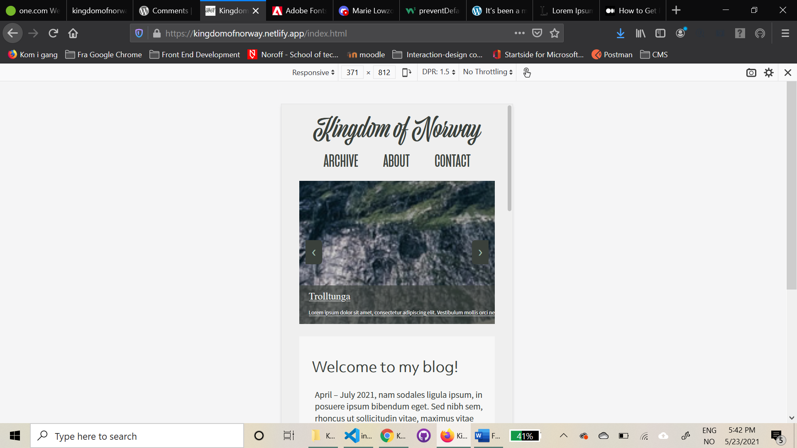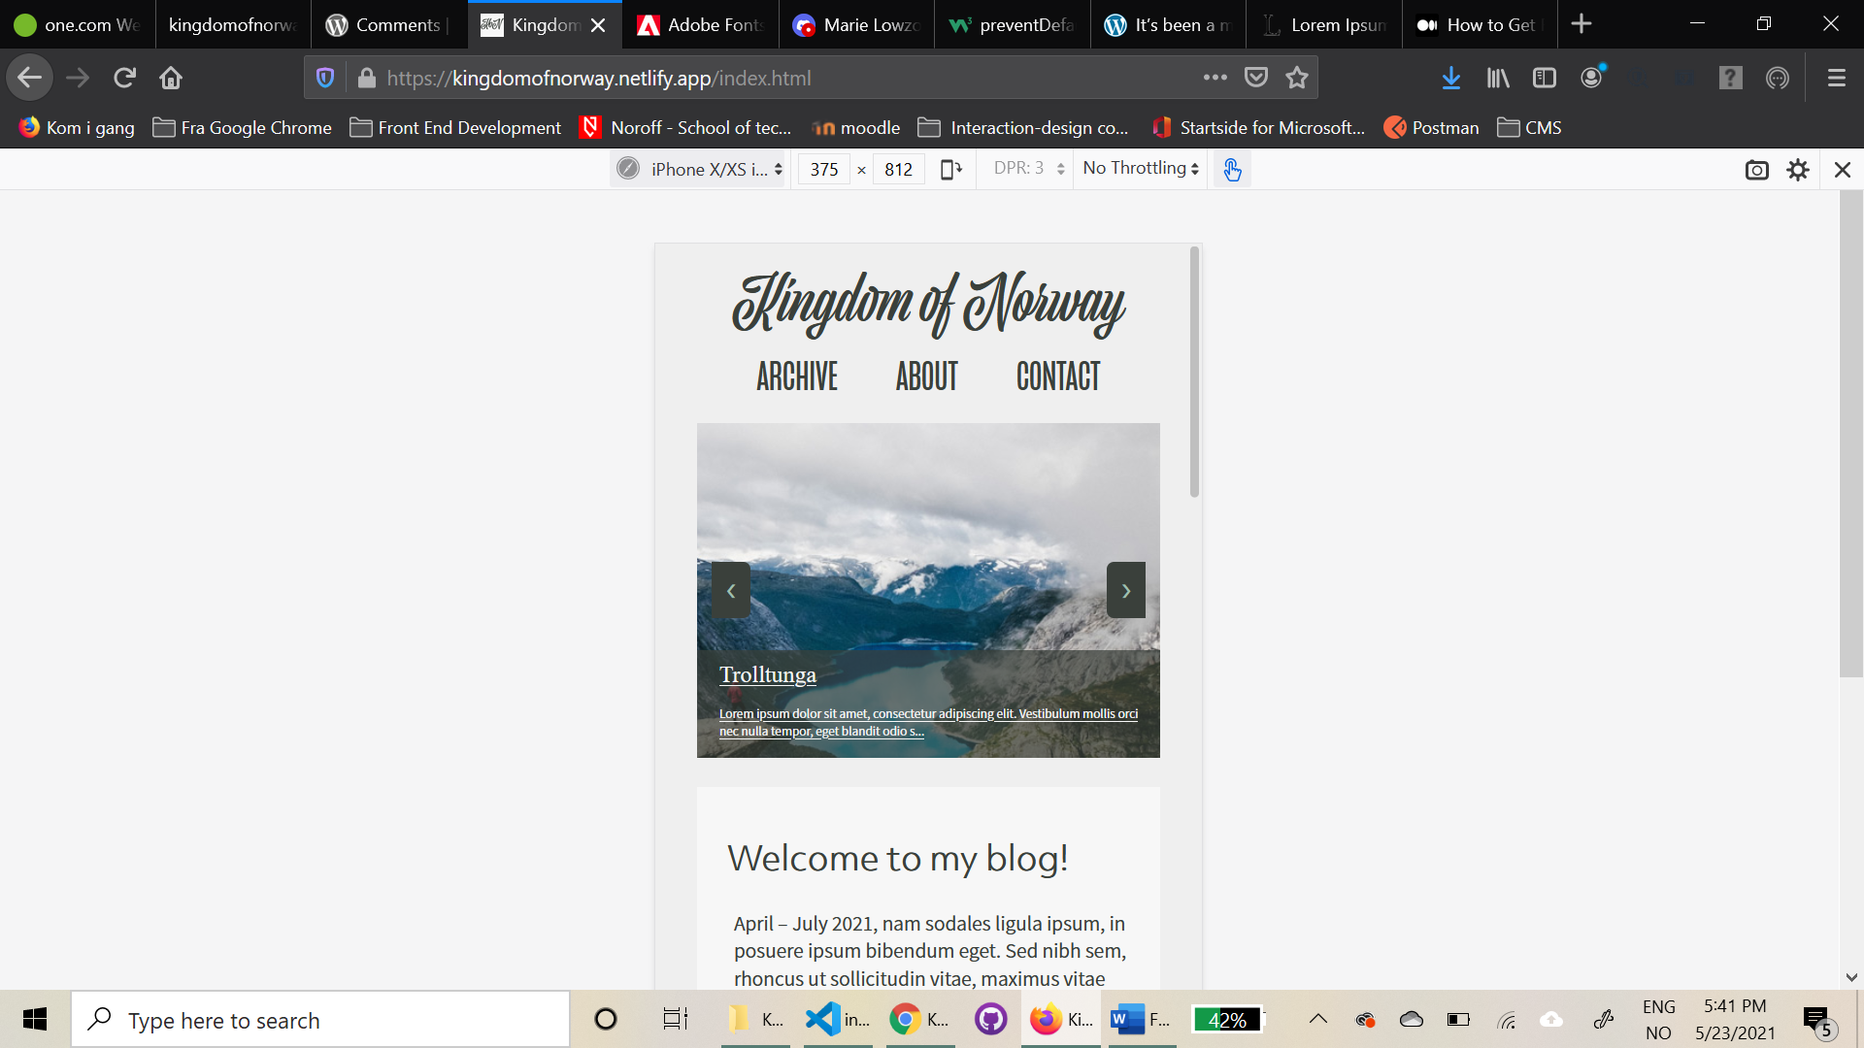

Figure

Figure

### What would you do differently next time

Next time I would try making a carousel with hardcoded HTML, and not build it dynamically with JavaScipt. I am not sure it will make any difference, but it will be one less thing to think about. I would also start earlier with the things I’m insecure about or have never done before. And I would try to make a carousel that is actually a carousel that goes in a loop.

Next time I would try to be more effective with everything, and try to do the Level 2 tasks as well.

## WCAG guidelines, content management and SEO

### What went well on the project

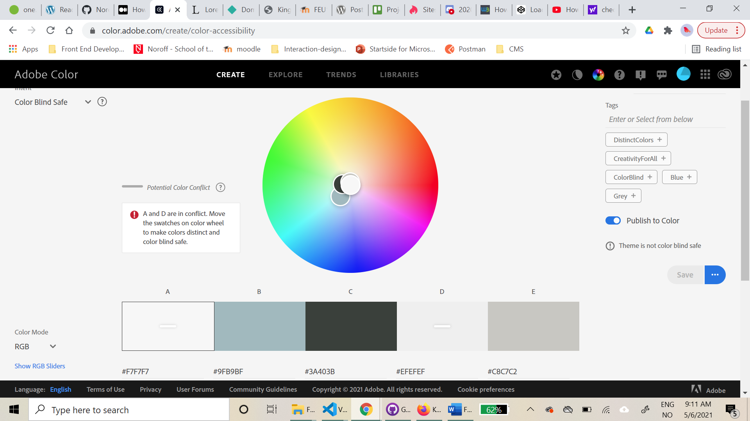

Figure 8

Because I wanted a calm and earthly colour pallette, I used Adobe Color[7] to get colors from one of the photographs I got for the blog. Because Adobe color has its own accessibility colour checker (figure 8), I knew that the colours were okay to use in my design. It was critical to two of the colours though, but I was not planning to use the colours to something important, and will not use them as a text-colour and background-colour together, so I wanted to test them “in action” before I changed them. When the site was up and running I tested it with the toptal color filter[8], and it passed the test (figure 9).

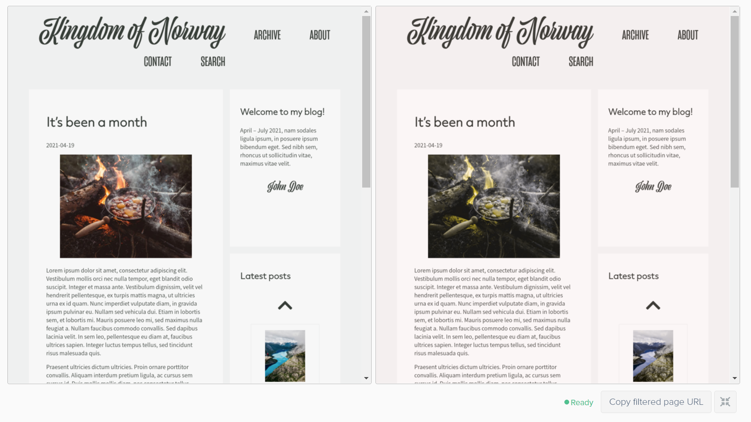

Figure 9 – Using Toptal colour filter on my site

A fellow student recommended me to use a chrome plugin called WAVE evaluation tool[9], which is a web accessibility evaluation tool that checks for correct heading numbers, labels, inputs, alt text, errors etc. I clicked through my site and dealt with the things that was not good enough (figure 9).

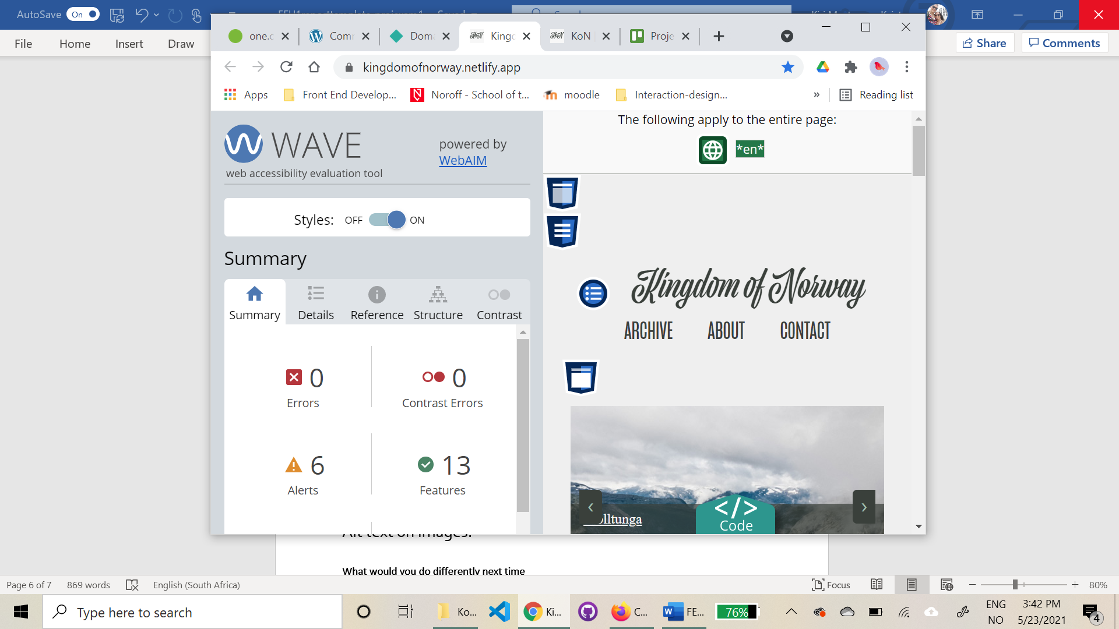

Figure 10 –using the WAVE evaluation tool on my site

I made a Trello[10] board (figure 10) with the lists “to do – doing – done”, then added cards with tasks that needed to be done in order to finish the project. The board is helpful to keep me on track, and to not forget something.

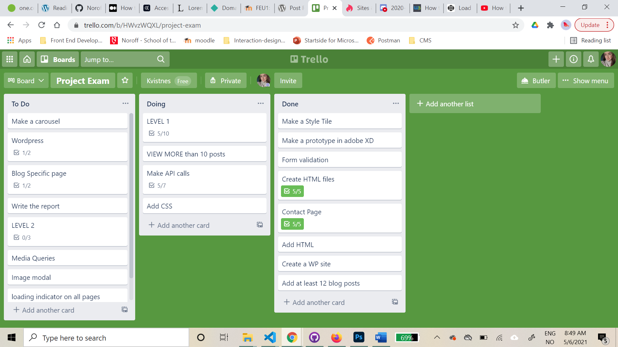

Figure 11 – my trello board

### Feedback and Hotjar data

I asked my friends, family, boyfriend and colleges for feedback and to click through my site for hotjar recordings.

As said earlier in the report, I got feedback from a few about the page needing more colours, and the colours being dull, so I adjusted it to give it a little more colour, yet not much. When asking the same persons what they thought after the changes, they thought it looked good.

I got a lot of positive feedback about the site looking clean, nice and professional, which is nice and motivating to hear.

When looking through the hotjar recordings, it seems like the site is simple to navigate through, and the user flow looks good.

### What was difficult/didn’t go well on the project

Adding alt text on the images from wp. I didn’t figure out how to access it at first, but found out that I had to add the alt text with the images in the media library in WordPress.

### What would you do differently next time

Learn more about WCAG guidelines, content management and SEO, because I don’t know what I could have done differently, but I’m sure there is a lot.

## References

(place references to websites, books, forums etc. that helped you in the project)

Adobe, adobe color. Url: <https://color.adobe.com/>

Adobe, adobe stock photos. Url: <https://stock.adobe.com/no/>

Dale, Nguyen, How to get featured image from WordPress REST API. Url: <https://dalenguyen.medium.com/how-to-get-featured-image-from-wordpress-rest-api-5e023b9896c6>

Jon Duckett, JavaScript and jQuery – interactive front-end web development, p. 129

Kevin Powell, How to code a carousel with HTML, CSS and JavaScript - from scratch. (3 Jan, 2019). Url: <https://www.youtube.com/watch?v=VYsVOamdB0g> & <https://www.youtube.com/watch?v=gBzsE0oieio&t=1543s> (18.05.2021)

Noroff, different lessons from the school year 20/21.

Toptal. Url: <https://www.toptal.com/designers/colorfilter>

Trello. Url: [www.trello.com](http://www.trello.com)

Unsplash, The internet’s source of freely usable images. Url: <https://unsplash.com/>

WAVE Evaluation Tool. Url: <https://chrome.google.com/webstore/detail/wave-evaluation-tool/jbbplnpkjmmeebjpijfedlgcdilocofh>

WordPress, REST API handbook. Url: <https://developer.wordpress.org/rest-api/reference/posts/#arguments>

WordPress, Support - Rest API only returns 10 posts. Url: <https://wordpress.org/support/topic/rest-api-only-returns-10-posts-2/>

W3Schools, CSS3 Images (image modal). Url: [https://www.w3schools.com/css/css3_images.asp /](https://www.w3schools.com/css/css3_images.asp%20/)

W3Schools, How to add an image in the title bar. Url: <https://www.w3docs.com/snippets/html/how-to-add-an-image-in-the-title-bar.html>

1. www.fonts.adobe.com
2. www.unsplash.com
3. www.stock.adobe.com/no
4. Dale Nguyen <https://dalenguyen.medium.com/how-to-get-featured-image-from-wordpressrest-api-5e023b9896c6>
5. <https://wordpress.org/support/topic/rest-api-only-returns-10-posts-2/>
6. Kevin Powell (Jan 3, 2019) - <https://www.youtube.com/watch?v=gBzsE0oieio&t=1543s>
7. <https://color.adobe.com/>
8. <https://www.toptal.com/designers/colorfilter>
9. <https://chrome.google.com/webstore/detail/wave-evaluation-tool/jbbplnpkjmmeebjpijfedlgcdilocofh>
10. [www.trello.com](http://www.trello.com)